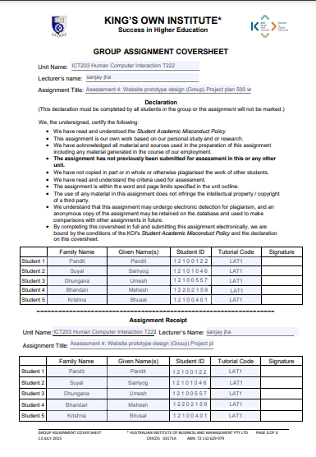

Contents

Introduction 2

Objectives of the website 2

Task Division 2

Design 3

Work Breakdown Structure 9

Gantt chart 9

Title of the website: Visit Nepal 2023

# Introduction

We are group of five members. We have decided to design website for VISIT NEPAL 2023. The main aim to design this website is to introduce our country Worldwide through internet and encourage tourists to visit once in Nepal. Nepal is a very beautiful country with unique different culture, art, and tradition, out of 10 highest peaks ,8 is found in Nepal even though few tourists visit Nepal due to lack of information. So, we are developing user friendly website which includes all the information.

This website consists of eight pages with homepage, places of Nepal, restaurant, menu page, contact us, about us and so on.

# Objectives of the website

Our main objectives are to attract people toward Nepal for tourism industry however more detail expiations are below.

* Provide proper vision of Nepal where most of the people have different perspective about Nepal then it is in real
* Help restaurants and tourism industry to grow
* Provide online services then traditional services
* Guide the people to places

# Task Division

Website development is the huge process, in our team member we divide the task between each other with make project complexation faster and smooth.

|  |  |  |
| --- | --- | --- |
| NAME | ROLE | RESPONSIBILITIES |
| Umesh Dhungana | User experience (UX) developers | Design initial mock-up of the website, UX designers fine-tune the design, functionality |
| Mahesh Bhandari | Front-end developers | create an attractive, functional, efficient interface for the user |
| Prasanna Pandit | Back-end developers | implementing APIs and building and integrating databases that support the front end. |
| Krishna Bhusal | User interface (UI) designers | Create user friendly website by using different colour, fonts and design, make site effective and attractive |

# Design

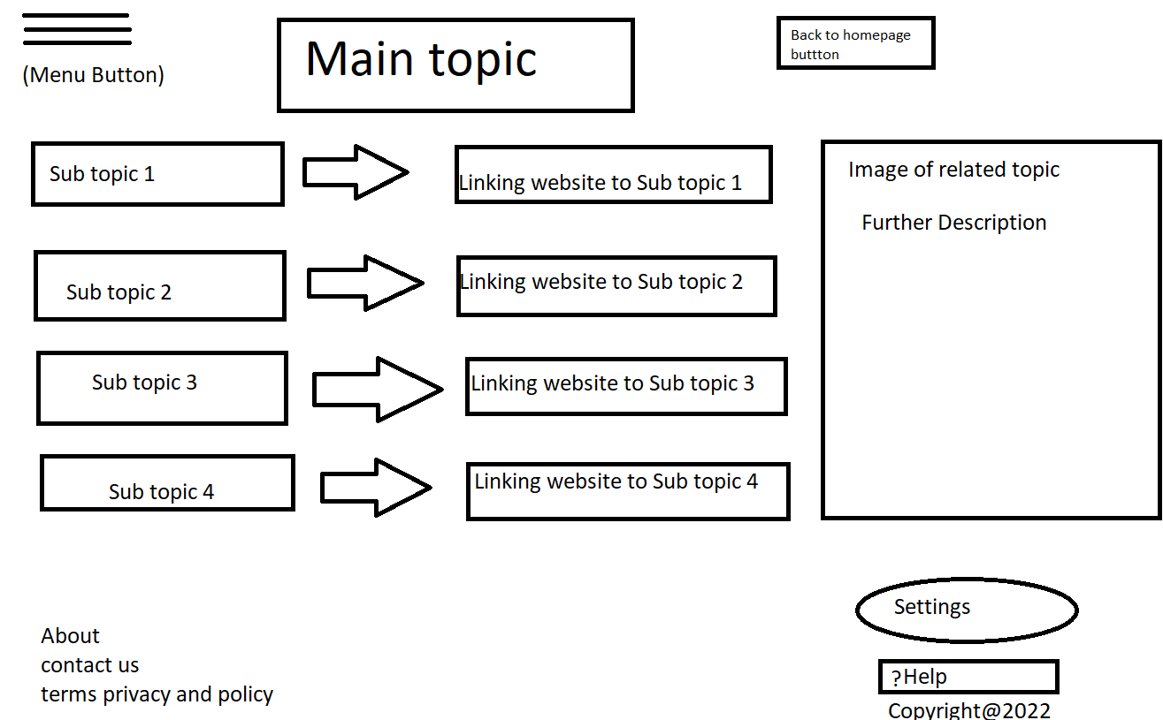

The main page or home page is the most important of any website as it includes almost everything of a website in the given picture we have prepared the format for menu button in which consists of various subtopic including main topic after that we have got a button to return to the homepage after that we have provided the linking website to every subtopic as the user are interested further regarding it after we click on certain topic there appears a picture of the given services along with pictures which helps user to know if they are looking the required thing or not at last we have got about button contact us and terms and privacy policy along with settings and help button.

At last, we have got our copyright claim on the page so that it can’t be duplicated

The about menu consists of message regarding the page such as date of establishment, purpose of establishing the page and the total costumer reach. Moreover, it has got contact list and FAQ. Beside that you can provide the feedback regarding the service provided and as well we can also read the privacy policy and terms and conditions.

Services page consists of the service provided in the given page the given picture comprises of the service page designed by us.it consists of topics like our services and list of services available. It also consists of image related to the service provided with further description. After that we have place the major two services provided by us and mostly used by our users. We have also place contact list like phone number and e-mail. After that I have placed reviews of our users related to the user experience

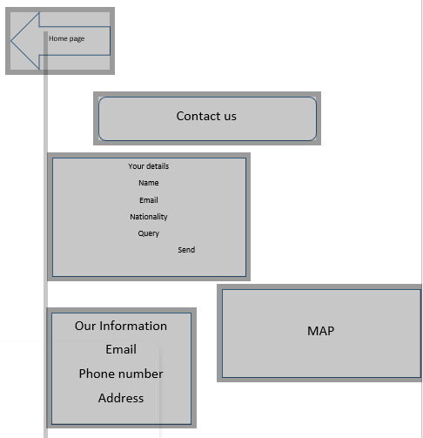

Contacts Us Page consists of your details which include of your name email Nationality and query. You can also contact us via email or phone number. It also consists of Google map which directs to our location.

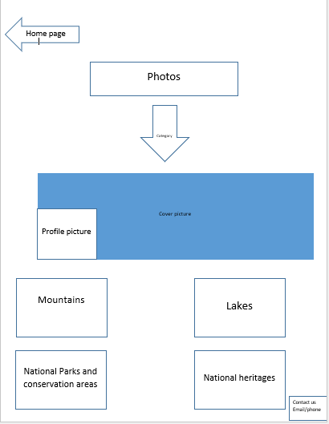

Photos page consists of cover photo and profile photo. It also consists of places category where tourists can visit. Category page consists of 4 major category like Mountains, Lakes, National Parks and Conservation areas and national heritages.

Booking page consists of hotel and room photos. It also consists of booking details like check in and out date number of adult and children and numbers of room needed.

# Work Breakdown Structure

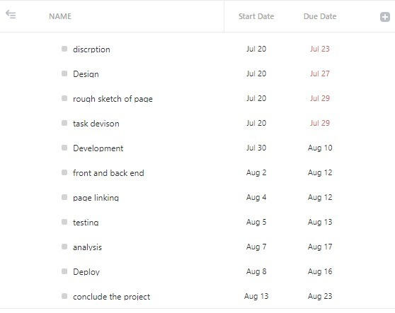

# Gantt chart

